AMERICAN CAR CRAFT INSTRUCTION

G8 Polished Stainless Hood Panel
PART# 223001

PARTS INCLUDED:
1-Stainless Vented Hood Panel
6-3/8” #8 Pan Head Screws
6-Chrome Screw Covers
6-White Nylon Sockets

Your hood panel comes to you with a protective liner. Do not remove liner until prompted by instructions.

1. Remove the hood. Mark the bolt head locations to the factory hood bracket with a fine marker.
In order to remove the hood successfully you will need three people, two to hold the hood secure at both sides and one to remove the bolts. Before you remove the hood prepare a sturdy table with a nice soft quilt or blanket to protect the paint. Remove the hood and set it face down exposing the underside.

2. Remove the factory hood liner. This will NOT be reused. Don’t worry the new stainless hood panel will provide an adequate thermal barrier and will protect the paint from engine heat.

3. Spray a little flat black paint over the hood vent area to darken these two spots. This will create the best look for the new panel vent grilles.

4. Apply a couple of golf ball size blob of clear 100% silicone to the top center areas of the factory hoods sub frame. When these cure against the new hood panel they will provide a nice stable bond to the top area of the hood and reduce vibration. If you like you can apply the silicone to other areas of the sub frame as well. Carefully set the hood panel in place centering it perfectly. You have been provided with six 3/8” #8 pan head screws and six chrome screw covers and sockets. Because the sub frame is made of a very thin metal you will be able to self tap the screws right into the sub frame using a good screw gun.

5. Insert all of the screws into the white nylon sockets provided. Hold the end of the screw gun tip and screw so that you stabilize the screw as you apply strong pressure to install the screw. This will prevent you from slipping as you install the screw. If you prefer you can predrilled the hole locations with a 1/8” drill bit but be VERY careful not to poke the hoods outer skin! After all six screws have been installed remove the protective liner and then snap on the chrome screw covers to finish the installation. Then simply reinstall the hood.
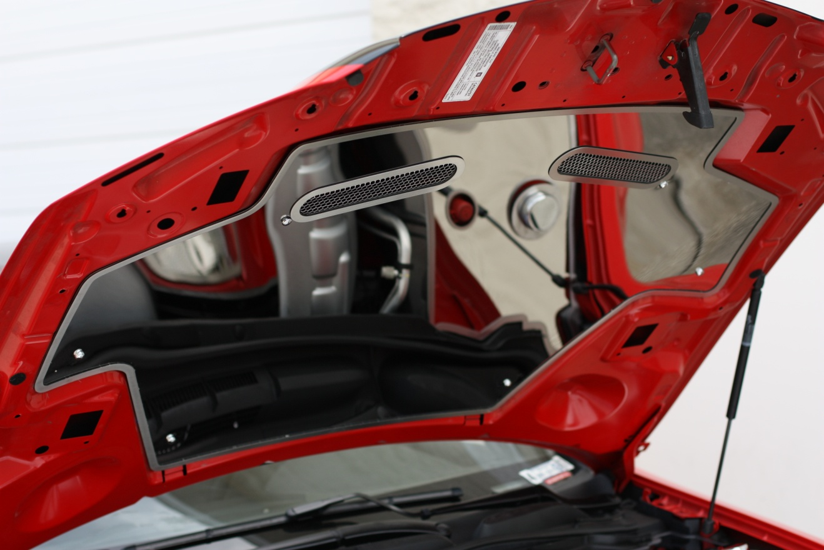

If any questions occur during installation please call:
American Car Craft at 727 861-1500

Thank you and enjoy your purchase!

CARE AND MAINTENANCE:
Note: Care must be taken when cleaning your hood panel. It is a good idea to lightly dust your panel with a clean soft cloth first in order to prevent any particles from scratching it. Then wipe (using a new clean soft cloth) with a good quality streak free glass cleaner. SEE CARE SHEET!

