AMERICAN CAR CRAFT
18924 SAKERA ROAD-HUDSON FLORIDA 34667
Phone # 727-861-1500 Fax # 727-861-1520
www.americancarcraft.com

INSTALLATION INSTRUCTIONS FOR THE
CAMARO 3PC HOOD PANEL
PART # CMHP100
PARTS INCLUDED:
___1-Stainless Large Hood Panel
___2-Stainless Small Hood Inserts
___2-Adhesive Promoter Packs
___1-Adhesive Promoter Tube
___2-Lengths of ¼” Chrome Trim
___6-3/8” #8 Pan Head Screws
___6-White Nylon Washers
___6-Chrome Screw Covers
___4-Small Polished Head Washer Self Tapping Screws

Your hood panel comes to you with a protective liner. Do not remove liner until prompted by instructions.

The new Camaro stainless steel hood panel has been designed to fit perfectly into the stock hood replacing the factory hood liner as an adequate thermal barrier. The new panel also considers hood clearance for the factory engine ONLY and does not take into consideration for any other aftermarket installations such as cold air filter systems and or performance modifications. NOTE: After market cold air systems generally contain heat shields that are designed to seal against the factory hood pad and should be considered for modification for application against the stainless hood panel!

- In order to correctly install the new stainless hood panel it will be necessary to remove the hood from the car. This procedure is relatively easy with the assistance of two helpers to hold the hood as you release it from the hinges. The first step will be to mark each of the hood bolts to the hood hinge by tracing the bolt washer to the hinge bracket with a fine marker. This will enable you to re bolt the hood back into the exact location it was before removal. Detach the washer fluid tube from its connector at the driver’s side of the wiper cowl. Have your two helpers support the hood at the corner closest to the wind shield making sure that they have a secure grip at this corner of the hood. This will prevent the hood from colliding with the wind shield and or the painted fender. With the hood firmly griped at both sides release the hoods gas prop by using a small pick to release the hood props band clip from the hoods ball stud and lay the prop down. Now remove all four hood bolts to release the hood and then set it belly up onto a nicely protected table. A common household blanket will work just great to protect the paint. Place a couple of paper towel rolls under both sides of the hood cowl to stabilize the hood. Now that the hood is securely set remove the factory hood liner retainers and the liner itself. NOTE: The factory hood liner will not be reused.

- You will notice two small recessed areas to the right and left on the hood area closest to the cowl area. Prepare these two areas by scrubbing them thoroughly with alcohol to remove any and all dirt and dust. Then swipe the entire area with the adhesive promoter provided.

- You have been provided with two small hood sections designed to fit into the two recessed areas. To permanently install them you will need to apply a large pile of 100% clear household silicone directly to the center of these areas. Pile the silicone high so that you can be sure that the silicone will make good contact with the small sections. Peel the red release liner from the back of the two small sections and then press them into place. The attachment tape will hold the two small sections firmly in place as the silicone sets.

- You have been provided with a single adhesive promoter snap tube. Use the tube to apply a single bead of adhesive promoter along the painted edge of the two small sections you just installed. You have also been provided with two small lengths of chrome trim. Peel the red release liner from the back of the trim and apply it directly to the paint against the outer edge of the two stainless sections to finish them.

- Now that the two small sections have been successfully installed you can proceed to the large main hood panel. Carefully set the panel into the hoods sub frame and adjust its position so that it is nice and symmetrical. Mark the hood panels ten mounting holes to the sub frame with a fine marker and remove the panel. Pilot each of the hole locations with a 9/64 drill bit. Be especially careful not to poke the outer skin of the hood as this will ruin the entire installation. TECH TIP: Create a useful drill stop cutting a common ball point pen tube to allow the drill tip to protrude out about 1/8 of an inch. This will prevent the drill from poking down too far and protect the outer hood surface. Once you have drilled all the hole locations, remove the panel’s protective liner then carefully reset the main hood panel back in place and align the panel with the holes you just piloted.

- You have been provided with six chrome screw covers and sockets as well as six 3/8 long #8 pan head screws. These screws will be used for the center main section attachment. You have also been provided with four small head washer type self taping screws to be used at the hood panels outer edge areas. Two at the top end of the hood and two at the lower cowl area. Place the main screws thru their white sockets and secure the hood. Snap the six chrome screw covers over the white sockets to finish the appearance of these screws. TECH TIP: Use a small pick to line each of the holes before you install each of the screws and carefully snug the screws. Do not over tighten them as this will tend to distort the hood panel. A small dab of instant adhesive will serve well to prevent any of the screws to loosen over time from road vibrations. Once the six main screws have been installed, line up the remaining holes once again with you pick and install the remaining four polished washer head screws.

- Carefully lift the hood with you two helpers and reattach the hood back into place exactly how it was removed aligning the bolts of the hood to the hood hinge locations you drew earlier. Snap the hood prop back onto the hood prop stud and reattach the washer fluid supply tube to finish the installation.

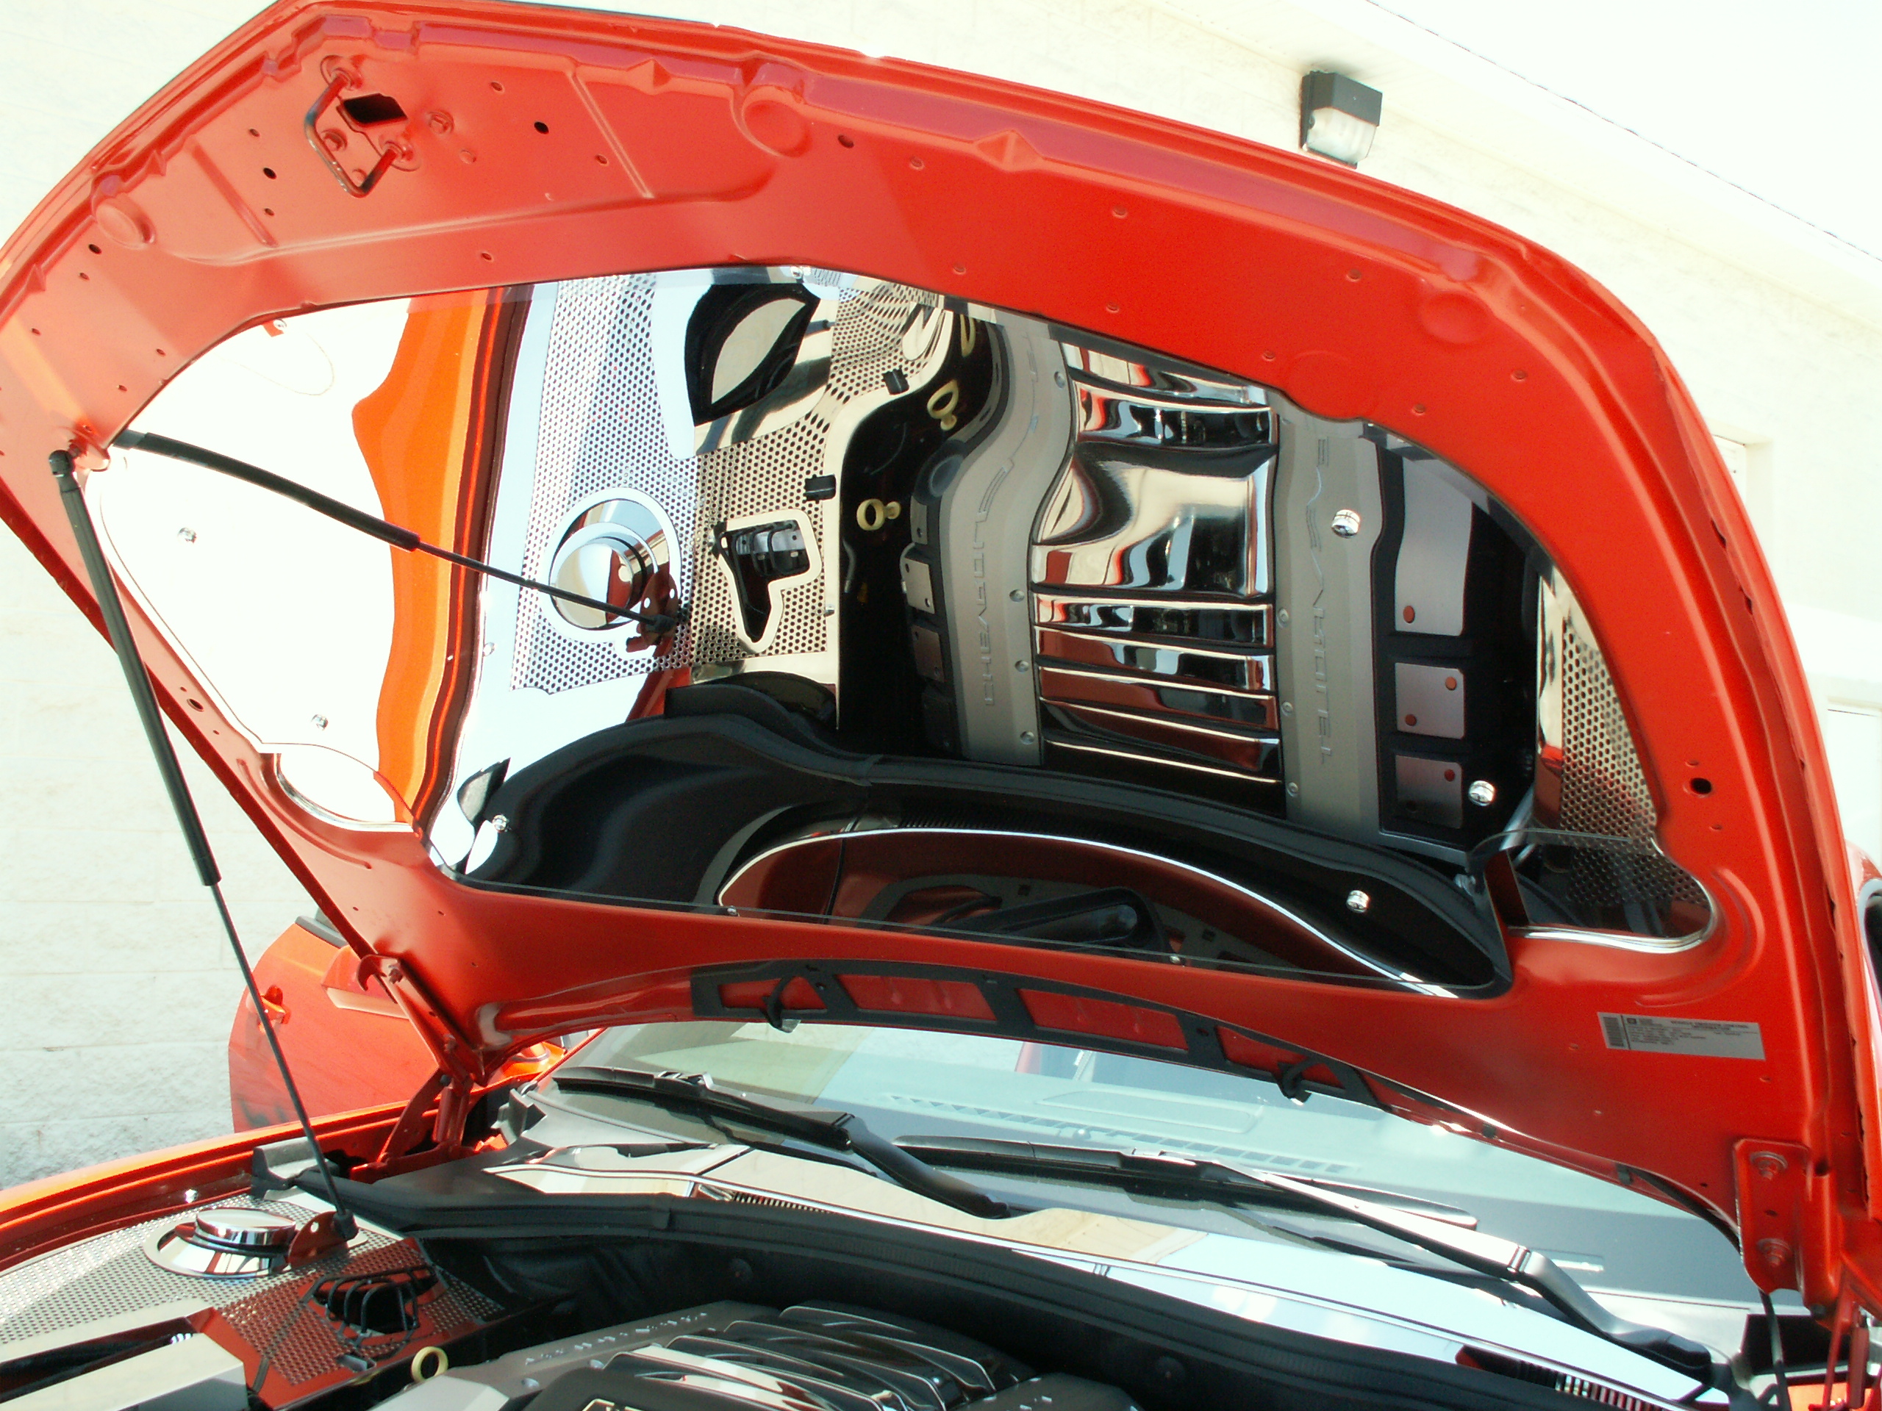
If any questions occur during installation please call American Car Craft at 727 861-1500.

Thank you and enjoy your purchase!

CARE AND MAINTENANCE:
Note: Care must be taken when cleaning your hood panel. It is a good idea to lightly dust your panel with a clean soft cloth first in order to prevent any particles from scratching it. Then wipe (using a new clean soft cloth) with a good quality streak free glass cleaner. SEE CARE SHEET!

