AMERICAN CAR CRAFT INSTRUCTIONS

C5 2-pc LASER MESH STAINLESS VENT GRILLES

PART #032021

PARTS INCLUDED:
2-Stainless Vent Grille w/attachment tape
2-Adhesive Promoter Packs
2- 23”Lengths 1/8” Chrome Molding

- Jack up the front of the car and secure with a pair of jack stands to ensure safety.

- Turn the front tire sharply to create adequate working clearance. Remove the retainers that secure the plastic inner fender well to the painted outer fender. Doing this creates access to the inner side of the fender vent hole. Once you have created this access you will need to remove two additional screws that are securing the vent deflector and remove the deflector. This will create full access to the vent hole.

- VERY IMPORTANT: Using a cloth with soap and water wipe the inner side of the vent on both sides of the hole to remove road grime and dirt. Once this area is clean scrub both sides of the vent hole with household isopropyl alcohol until thoroughly clean.

- You have been provided with two packets of adhesive promoter. Use one of them and swipe the inner and outer sections of the inside of the vent hole.

- Place the vent grill into position behind the vent hole and check the fit. It may be necessary to adjust the vent grille by hand in order to achieve a nice perfect fit. Adjustments can easily be made by forcing the shape against the floor to curve the tips if needed and use pliers to spread or contract the angle of all the tabs if necessary to achieve a nice contoured fit.

- Once the grille has been fitted you may begin permanent installation. Peel the red liner from the attachment tape and firmly set into position being sure to firmly press both the vent grille on the inside and the vent opening on the outside fender simultaneously in order to achieve a full permanent bond.

- Reattach the inner vent deflector as well as the inner fender well and retainers.

- You have been supplied with two lengths of chrome trim. Should you elect to use this trim it has been provided to be applied to the outer edge of the vent hole to give the opening a more complete look. Before you begin installation you must first prepare the surface by scrubbing the area with household rubbing alcohol then swipe the area once with the remaining adhesive promoter. Begin at the inner most center of the vent opening. Remove a small section of the red release liner as you begin placement press the trim into position and work your way to the corners. As you approach each corner you will need to pre-bend the trim so that it takes the shape of the corner without forcing it. Once you have achieved this press the trim with some force into each corner this will ensure the trim maintains a permanent shape. As you approach the start point snip the excess trim off with a scissors leaving a little extra length so that you will have to buckle the trim into a nice tight butt seam.

- Repeat steps 1-8 for opposite side.

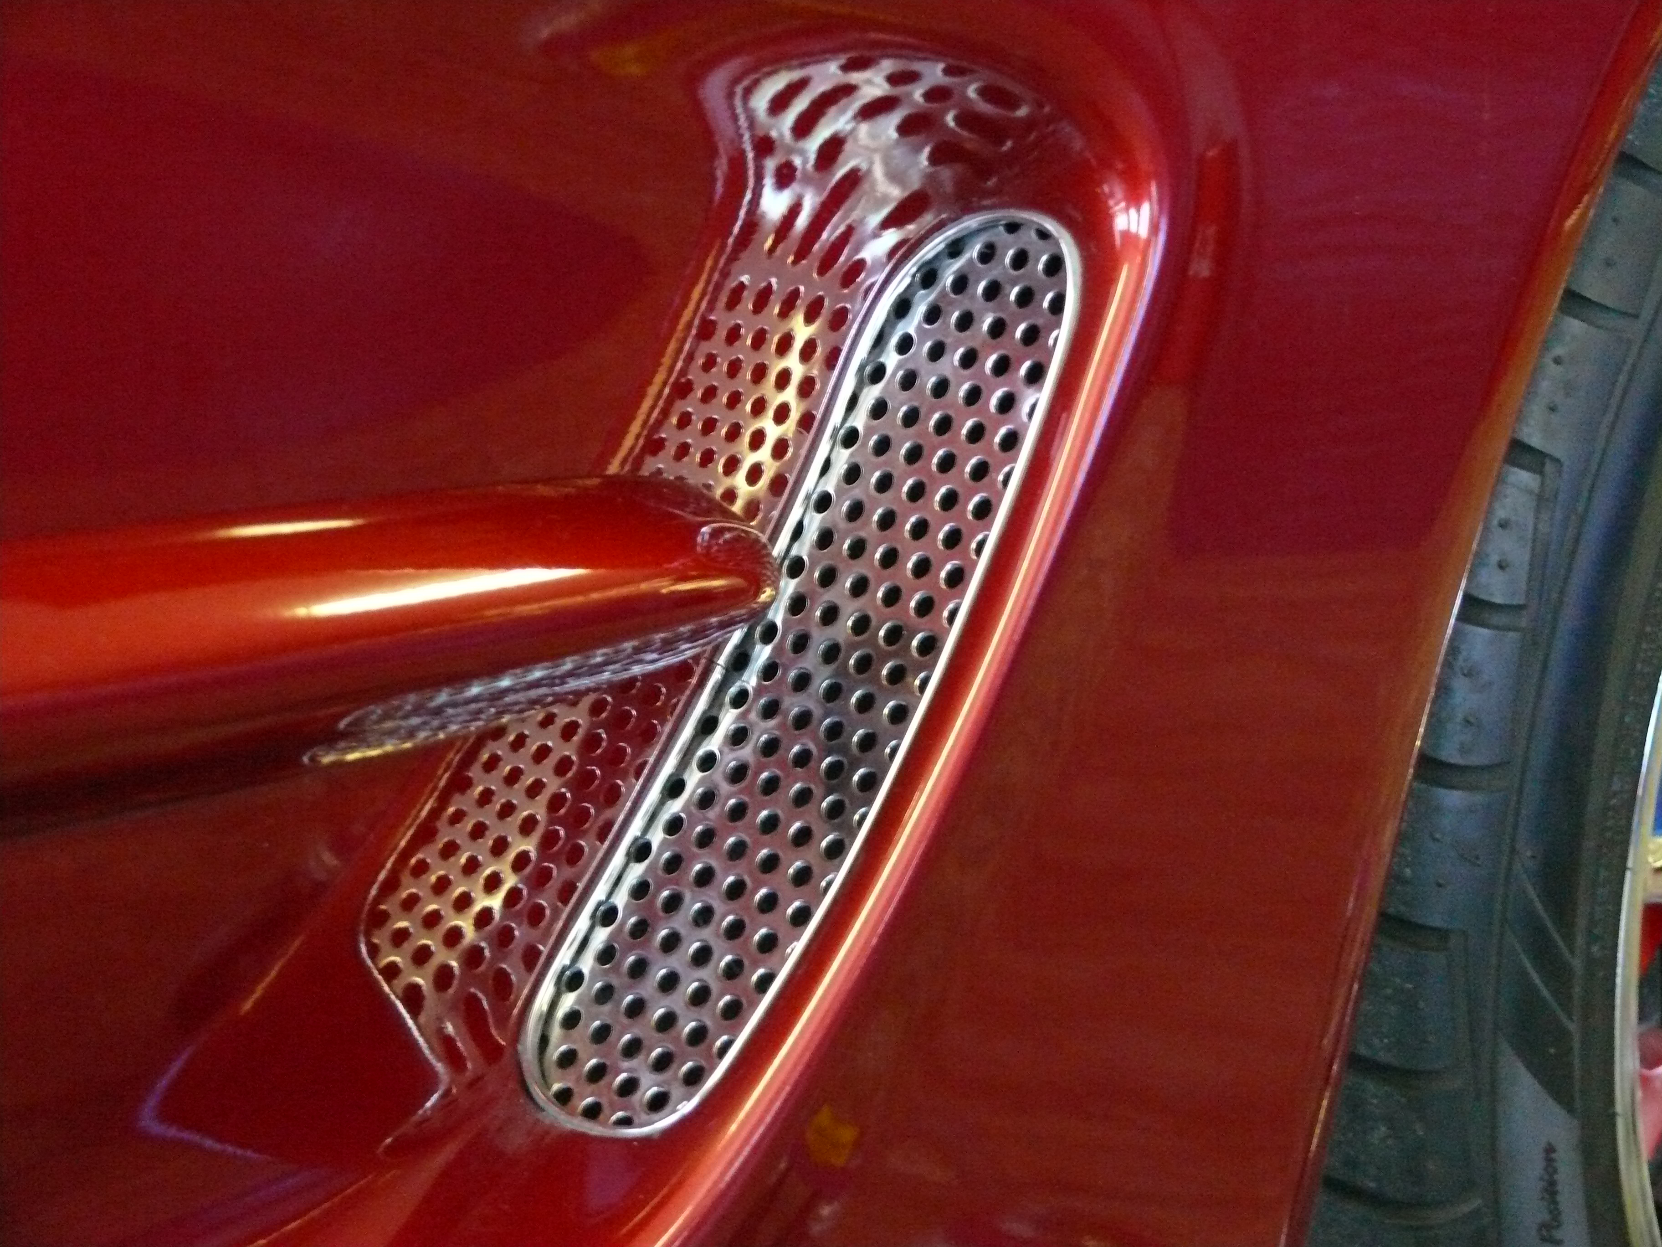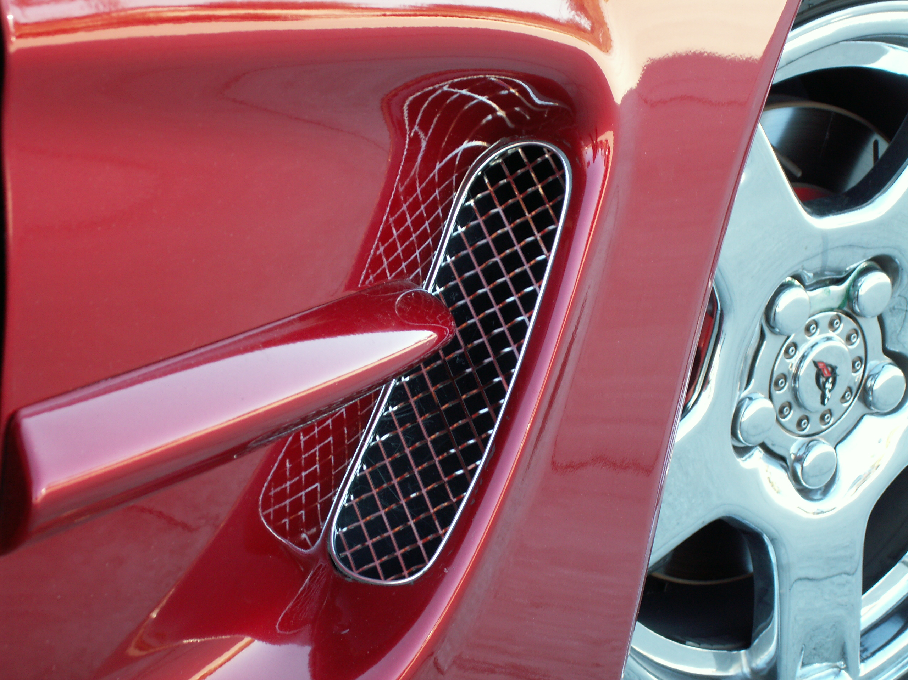

If any questions occur during installation please call American Car Craft at 727 861-1500.
Thank you and enjoy your purchase!

